Gmirror howto (FreeBSD 7.0)

1. Install FreeBSD normally

2. When finished, reboot and boot with CD4 which contains the live filesystem.
3. Choose Choice Fixit Repair mode with CDROM/...

4. When asked choose choice 2. Live DVD/CD
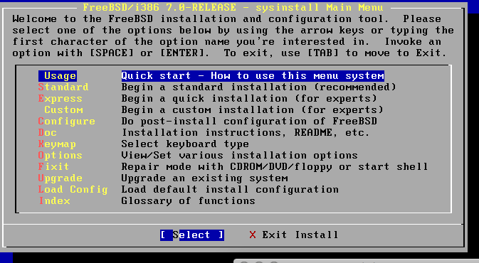
5. Once at the prompt, load the GEOM MIRROR kernel module:

# kldload /dist/boot/kernel/geom_mirror.ko

6. Label the mirror, let's call it system and start with disk /dev/ad0

# gmirror label system /dev/ad0

You now have a new virtual disk call /dev/mirror/system which contains the same partitions of /dev/ad0 (s1a, s1b, ...)

7. Let's tell the system that from now on, we want geom_mirror to be loaded at boot:

# mount /dev/mirror/systems1a /mnt

8. vi /mnt/boot/loader.conf, and add:

geom_mirror_load="YES"

... and save + exit.

9. Now we need to change /mnt/etc/fstab, and change ALL references of

'ad0' to 'mirror/system', i.e.: /dev/ad0s1a -> /dev/mirror/systems1a,
/dev/ad0s1b -> /dev/mirror/systems1b, etc... and save + exit.

10. exit, quit sysinstall, and reboot

11. once the system is booted, log in as root and check your list of disks
to see which is disk 2:

# atacontrol list

The disk you are looking for might be ad1 or ad2 or ad4, at least as big as ad0.

12. Once you have identified it, run:

# gmirror insert system /dev/adX # ad1 or ad2 or whatever disk

It shoud now say:

GEOM_MIRROR: Device system: rebuilding provider adX.

14. Run gmirror status to see progress
You can also run gstat to see disk activity...

15. You are done!

