IPv4 ADDRESSING SCHEME – MODULES 1 to 5

Figure 1 below displays the addressing plan to be used for Modules 1 to 5. The plan itself is explained in the notes accompanying the workshop Modules.

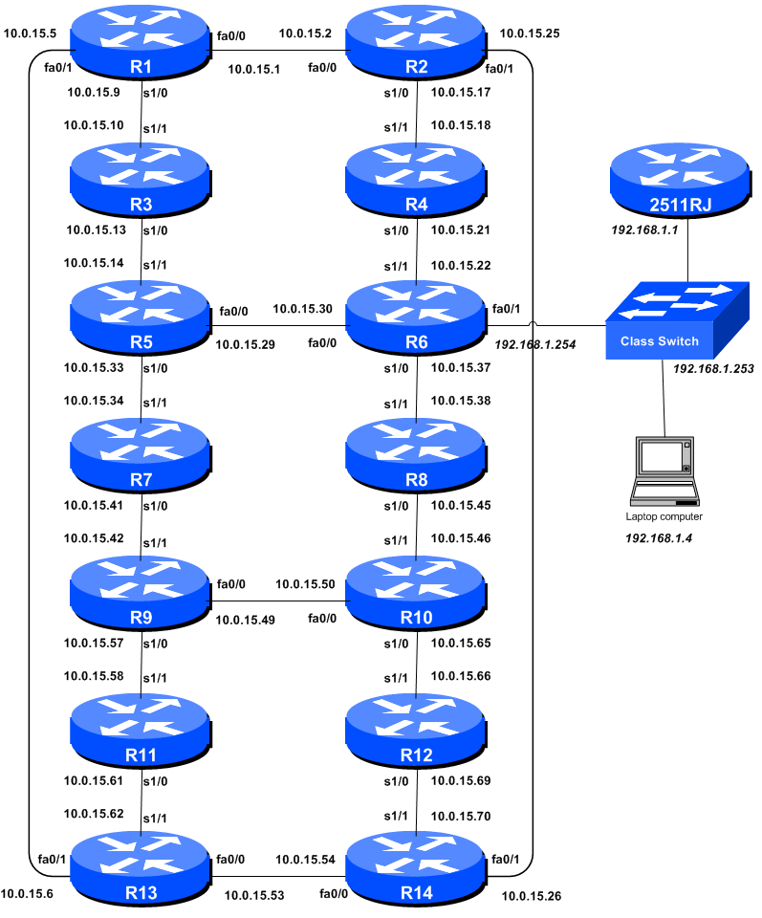
Figure 1 – Addressing Scheme for Modules 1 to 5

IPv4 Addresses – Modules 1 to 5

Router | Loopback Address |  | Router | Loopback Address
R1 | 10.0.15.241 |  | R8 | 10.0.15.248
R2 | 10.0.15.242 |  | R9 | 10.0.15.249
R3 | 10.0.15.243 |  | R10 | 10.0.15.250
R4 | 10.0.15.244 |  | R11 | 10.0.15.251
R5 | 10.0.15.245 |  | R12 | 10.0.15.252
R6 | 10.0.15.246 |  | R13 | 10.0.15.253
R7 | 10.0.15.247 |  | R14 | 10.0.15.254
Table 1 – IPv4 Loopback Address assigned to each Router in Modules 1 to 5

Router | “Customer” Address |  | Router | “Customer” Address
R1 | 10.0.0.0/26 |  | R8 | 10.0.1.192/26
R2 | 10.0.0.64/26 |  | R9 | 10.0.2.0/26
R3 | 10.0.0.128/26 |  | R10 | 10.0.2.64/26
R4 | 10.0.0.192/26 |  | R11 | 10.0.2.128/26
R5 | 10.0.1.0/26 |  | R12 | 10.0.2.192/26
R6 | 10.0.1.64/26 |  | R13 | 10.0.3.0/26
R7 | 10.0.1.128/26 |  | R14 | 10.0.3.64/26
Table 2 – IPv4 “Customer” Addresses assigned to each Router in Modules 1 to 5

IPv4 Netmask Table

Subnet Mask | Wild-Card Mask | Network Bits | Host Bits | Prefix
0.0.0.0 | 255.255.255.255 | 0 | 32 | /0
128.0.0.0 | 127.255.255.255 | 1 | 31 | /1
192.0.0.0 | 63.255.255.255 | 2 | 30 | /2
224.0.0.0 | 31.255.255.255 | 3 | 29 | /3
240.0.0.0 | 15.255.255.255 | 4 | 28 | /4
248.0.0.0 | 7.255.255.255 | 5 | 27 | /5
252.0.0.0 | 3.255.255.255 | 6 | 26 | /6
254.0.0.0 | 1.255.255.255 | 7 | 25 | /7
255.0.0.0 | 0.255.255.255 | 8 | 24 | /8
255.128.0.0 | 0.127.255.255 | 9 | 23 | /9
255.192.0.0 | 0.63.255.255 | 10 | 22 | /10
255.224.0.0 | 0.31.255.255 | 11 | 21 | /11
255.240.0.0 | 0.15.255.255 | 12 | 20 | /12
255.248.0.0 | 0.7.255.255 | 13 | 19 | /13
255.252.0.0 | 0.3.255.255 | 14 | 18 | /14
255.254.0.0 | 0.1.255.255 | 15 | 17 | /15
255.255.0.0 | 0.0.255.255 | 16 | 16 | /16
255.255.128.0 | 0.0.127.255 | 17 | 15 | /17
255.255.192.0 | 0.0.63.255 | 18 | 14 | /18
255.255.224.0 | 0.0.31.255 | 19 | 13 | /19
255.255.240.0 | 0.0.15.255 | 20 | 12 | /20
255.255.248.0 | 0.0.7.255 | 21 | 11 | /21
255.255.252.0 | 0.0.3.255 | 22 | 10 | /22
255.255.254.0 | 0.0.1.255 | 23 | 9 | /23
255.255.255.0 | 0.0.0.255 | 24 | 8 | /24
255.255.255.128 | 0.0.0.127 | 25 | 7 | /25
255.255.255.192 | 0.0.0.63 | 26 | 6 | /26
255.255.255.224 | 0.0.0.31 | 27 | 5 | /27
255.255.255.240 | 0.0.0.15 | 28 | 4 | /28
255.255.255.248 | 0.0.0.7 | 29 | 3 | /29
255.255.255.252 | 0.0.0.3 | 30 | 2 | /30
255.255.255.254 | 0.0.0.1 | 31 | 1 | /31
255.255.255.255 | 0.0.0.0 | 32 | 0 | /32
Table 3 – IPv4 Subnets

Subnet Mask The subnet mask of the CIDR block.
Wild-Card Mask Wild-Card Mask used in OSPF and packet filters
Network Bits The number of bits in the network part of the mask
Host Bits The number of bits in the host part of the mask
Prefix Short hand syntax of the CIDR block.

