Module 1c – iBGP

Objective: Create a basic physical lab interconnection with IGP and one BGP AS number. Ensure that all routers, interfaces, cables and connections are working properly.

Prerequisites: Module 1a (OSPF) or Module 1b (ISIS).

The following will be the common topology used for the first series of labs.

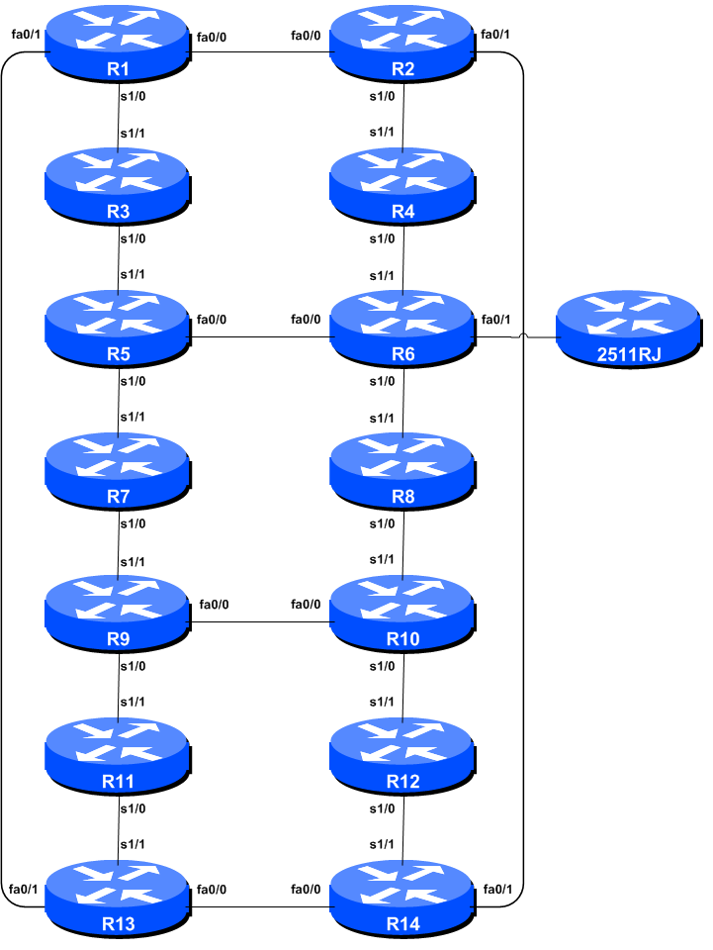

Figure 1 – ISP Lab Basic Configuration

Lab Notes

This workshop is intended to be run on a Dynamips server with the appropriate lab topologies set up. The routers in the Dynamips environment are using service provider IOS. The configurations and configuration principles discussed below will work on all Cisco IOS Release 12.4 onwards. Earlier Cisco IOS releases are not supported but will mostly work using the notes below; they will miss some of the features covered.

The purpose of this module is to construct the workshop lab and introduce everyone to the basic principles of constructing and configuring a network. An important point to remember, and one that will be emphasised time and again through out this workshop, is that there is a distinct sequence to building an operational network:

- After the physical design is established, the connections between the hardware should be built and verified.

- Next, the routers should have the base configuration installed, and basic but sufficient security should be set up.

- Next the basic IP connectivity be tested and proven. This means assigning IP addresses on all links which are to be used, and testing the links to the neighbouring devices.

- Only once one router can see its neighbour does it make sense to start configuring routing protocols. And start with the IGP (ISIS is chosen for this workshop). There is no purpose to building BGP while the chosen IGP (in this case ISIS) is not functioning properly. BGP relies on ISIS to find its neighbours and next hops, and an improperly or non-functioning ISIS will result in much time wasted attempting to debug routing problems.

- Once the IGP is functioning properly, the BGP configuration can be started, first internal BGP, then external BGP.

- Remember to RTFM. What is RTFM? It is critical that ISP Network Engineers fully utilise all information resources. The #1 source is the documentation. Read The F#$% Manual (RTFM) is the traditional phase used to inform engineers that the answer is in the documentation and go read it. We will use RTFM through out these exercises to highlight areas where the student should use the documentation for further deepening. There will be many new commands. Please refer to the IOS Command Reference on Cisco Connection Online (CCO.cisco.com) for details on each of these commands.

- Finally, documentation. Documentation is often overlooked or forgotten. It is an ongoing process in this workshop. If the instructor asks you to document something, either on the whiteboard in the class, or at the back of this booklet, it is in your best interests to do so. There can never be too much documentation, and documentation at the time of network design and construction can usually saves much frustration at a future date or event.

Lab Exercise

- Configuring iBGP. Before we set up iBGP with our neighbours in our AS, we need to do some basic preparation on the router. The IOS defaults are not optimised for Service Provider networks, so before we bring up BGP sessions, we should set the defaults that we require.

The default distance for eBGP is 20, the default distance for iBGP is 200, and the default distance for ISIS is 115. This means that there is a potential for a prefix learned by eBGP to override the identical prefix carried by ISIS. Recall from the Routing presentation that there is a distinct separation between BGP and ISIS processes – prefixes present in ISIS will never be found in BGP, and vice-versa. To protect against accidents, the eBGP distance is set to 200 also. The command to do this is the bgp distance subcommand, syntax is:

distance bgp <external-routes> <internal-routes> <local-routes>

Note: This should be included in all future BGP configurations in this workshop. For example, for Router2, the configuration might be:

Router2(config)#router bgp 10

Router2(config-router)#distance bgp 200 200 200

- Logging of BGP Adjacency State. Enable logging of BGP neighbour changes. This is so that a notification is generated every time the state of a BGP neighbour changes state, and is useful for debugging purposes:

Router2(config)#router bgp 10
Router2(config-router)# bgp log-neighbor-changes

Note: From IOS 12.3 onwards, bgp log-neighbor-changes is activated by default when BGP is first configured.

- Configuring iBGP Neighbours. All Routers will be in Autonomous System (AS) 10 for this first lab. Use the show ip bgp summary to check the peering. The BGP peering will be established using the loopback interfaces’ IP address.

Router2(config)#router bgp 10
Router2 (config-router)#neighbor 10.0.15.241 remote-as 10
Router2 (config-router)#neighbor 10.0.15.241 update-source loopback 0
Router2 (config-router)#neighbor 10.0.15.241 description iBGP with Router1
Router2 (config-router)#
Router2 (config-router)#neighbor 10.0.15.243 remote-as 10
Router2 (config-router)#neighbor 10.0.15.243 update-source loopback 0
Router2 (config-router)#neighbor 10.0.15.243 description iBGP with Router3
Router2 (config-router)#
Router2 (config-router)#neighbor 10.0.15.244 remote-as 10
Router2 (config-router)#neighbor 10.0.15.244 update-source loopback 0
Router2 (config-router)#neighbor 10.0.15.244 description iBGP with Router4
Router2 (config-router)#
Router2 (config-router)#neighbor 10.0.15.245 remote-as 10
Router2 (config-router)#neighbor 10.0.15.245 update-source loopback 0
Router2 (config-router)#neighbor 10.0.15.245 description iBGP with Router5
Router2 (config-router)#
Router2 (config-router)#neighbor 10.0.15.246 remote-as 10
Router2 (config-router)#neighbor 10.0.15.246 update-source loopback 0
Router2 (config-router)#neighbor 10.0.15.246 description iBGP with Router6
Router2 (config-router)#
Router2 (config-router)#neighbor 10.0.15.247 remote-as 10
Router2 (config-router)#neighbor 10.0.15.247 update-source loopback 0
Router2 (config-router)#neighbor 10.0.15.247 description iBGP with Router7
Router2 (config-router)#
Router2 (config-router)#neighbor 10.0.15.248 remote-as 10
Router2 (config-router)#neighbor 10.0.15.248 update-source loopback 0
Router2 (config-router)#neighbor 10.0.15.248 description iBGP with Router8
Router2 (config-router)#
Router2 (config-router)#neighbor 10.0.15.249 remote-as 10
Router2 (config-router)#neighbor 10.0.15.249 update-source loopback 0
Router2 (config-router)#neighbor 10.0.15.249 description iBGP with Router9
Router2 (config-router)#
Router2 (config-router)#neighbor 10.0.15.250 remote-as 10
Router2 (config-router)#neighbor 10.0.15.250 update-source loopback 0
Router2 (config-router)#neighbor 10.0.15.250 description iBGP with Router10
Router2 (config-router)#
Router2 (config-router)#neighbor 10.0.15.251 remote-as 10
Router2 (config-router)#neighbor 10.0.15.251 update-source loopback 0
Router2 (config-router)#neighbor 10.0.15.251 description iBGP with Router11
Router2 (config-router)#
Router2 (config-router)#neighbor 10.0.15.252 remote-as 10
Router2 (config-router)#neighbor 10.0.15.252 update-source loopback 0
Router2 (config-router)#neighbor 10.0.15.252 description iBGP with Router12
Router2 (config-router)#
Router2 (config-router)#neighbor 10.0.15.253 remote-as 10
Router2 (config-router)#neighbor 10.0.15.253 update-source loopback 0
Router2 (config-router)#neighbor 10.0.15.253 description iBGP with Router13
Router2 (config-router)#
Router2 (config-router)#neighbor 10.0.15.254 remote-as 10
Router2 (config-router)#neighbor 10.0.15.254 update-source loopback 0
Router2 (config-router)#neighbor 10.0.15.254 description iBGP with Router14

Q. Why is update-source loopback 0 necessary on iBGP?

Use show ip bgp summary to check the status of the iBGP neighbour connections. If the iBGP session is not up and/or no updates are being sent, work with the Router Team for that neighbour connection to troubleshoot the problem.

- Sanity Check. Remember to use the following commands to ensure you are getting the information you are suppose to be getting:

show ip bgp summary : see a list of BGP peers that the router sees
show ip bgp : see a list of BGP paths that the router sees
show ip route : see all the routes that the router has installed

Q. Are there routes seen via show ip bgp? If not, why not? Are there any routes tagged "B" when you do a show ip route?

- Add Networks via BGP. Each Router Team will use BGP to advertise the address block used for the Module. For example, Router Team 1 would add:

Router1 (config)#router bgp 10
Router1 (config-router)#network 10.0.0.0 mask 255.255.240.0

Use show ip bgp on neighbour’s router to see if you are advertising your network via BGP.

Q. Does the network show up via BGP? If not, why?

Enter a static route for the CIDR block. For example, Router 1 would use:

Router1 (config)#ip route 10.0.0.0 255.255.240.0 Null0

Q. Does the network show up via a neighbour’s BGP? Use the command show ip bgp neighbor <neighbour’s IP address> advertised-routes to see what you are exporting to the other router. Physically go to one of your neighbour’s routers and check their BGP Table. Explain what you see.

Q. Does the network appear in the router’s forwarding table? Use the command show ip route to check the local forwarding table. If not, why not?

- For Routers with IOS prior to 12.3 add the following commands to BGP:

Router1 (config)#router bgp 10
Router1 (config-router)# no synchronization
Router1 (config-router)# no auto-summary

Q. Does the network appear in the router’s forwarding table? Use the command show ip route to check the local forwarding table. What does the no synchronisation command do in BGP? How does it effect the router’s forwarding table?

Note: As from IOS 12.3, synchronization and auto-summarisation are disabled by default and do not appear in the default BGP configuration. These two features have not been required in Service Provider networks since the classless routing system was introduced to the Internet in 1994.

Checkpoint #1: call the lab assistant to verify the connectivity.

- Adding a “customer” route into BGP (Background & Example). We are now going to add a “customer” route into BGP on each router. Now in the lab we don’t have any “customers” as such connected to our routers, so we are going to simulate the connectivity by simply using a Null0 interface. As an example, in real life, the configuration to connect a customer would look something like this.

ip route 172.16.4.0 255.255.255.128 Serial 0/5/2 permanent

!

router bgp 64509

network 172.16.4.0 mask 255.255.255.128

!

This would add a static route pointing 172.16.4.0/25 towards Serial 0/5/2 – the latter interface would be a fixed link connecting to the customer site. 172.16.4.0/25 would be the address space that the ISP had assigned to the customer. The BGP network statement would then add the customer address block into the ISP’s iBGP.

Note: the permanent keyword ensures that the static route is always in the routing table, even if the interface physically goes down. Many ISPs use this to ensure they don’t have iBGP churn when their customer links go down.

- Adding a “customer” route into BGP. The “customer” address space that each router team will introduce into the iBGP is listed below – we will each use a /26, for simplicity’s sake.

R1 10.0.0.0/26
R2 10.0.0.64/26
R3 10.0.0.128/26
R4 10.0.0.192/26
R5 10.0.1.0/26
R6 10.0.1.64/26
R7 10.0.1.128/26
R8 10.0.1.192/26
R9 10.0.2.0/26
R10 10.0.2.64/26
R11 10.0.2.128/26
R12 10.0.2.192/26
R13 10.0.3.0/26
R14 10.0.3.64/26

Each team should now set up a static route pointing to the NULL0 interface for the /26 that they are to originate. Once the static is set up, the team should then add an entry into the BGP table. Here is an example for Router11:

Router11 (config)# ip route 10.0.2.128 255.255.255.192 Null0

Router11 (config)# router bgp 10

Router11 (config-router)# network 10.0.2.128 mask 255.255.255.192

- Check the BGP table. Are there routes seen via show ip bgp? If not, why not? Once every team in the class has done their configuration, each team should see the aggregate as well as the fourteen /26s introduced in the previous step. If this is not happening, work with your neighbours to fix the problem.

Checkpoint #2: call the lab assistant to demonstrate the current BGP table.

- Other Features in iBGP. Review the documentation or use command line help by typing ? to see other show commands and other BGP configuration features.

- Advanced Configuration. Those router teams who have completed this module should refer to Module 11 of the Advanced BGP Workshop. The set-up steps have been extended to include all the basic requirements of a router being used in an ISP backbone. While waiting for the module to complete, now would be a good time to review the advanced Module and incorporate the additions to the configuration used here.

Review Questions

- What IOS show command(s) will display the router’s BGP route table?

- Why change the eBGP distance from the default 20 to 200?

- Why is the static pull up route necessary in relation to inserting a prefix into iBGP?

There have been several incidents in the past where denial of service attacks on ISP networks have been successful because ISPs have omitted basic routing protocol security. Setting the BGP distances to be greater than any IGP is one of the mitigation methods available.

