IPv6 Module 6 – iBGP and Basic eBGP

Objective: Using IPv6, simulate four different interconnected ISP backbones using a combination of OSPF, internal BGP, and external BGP.

Prerequisites: Module 1

Topology :
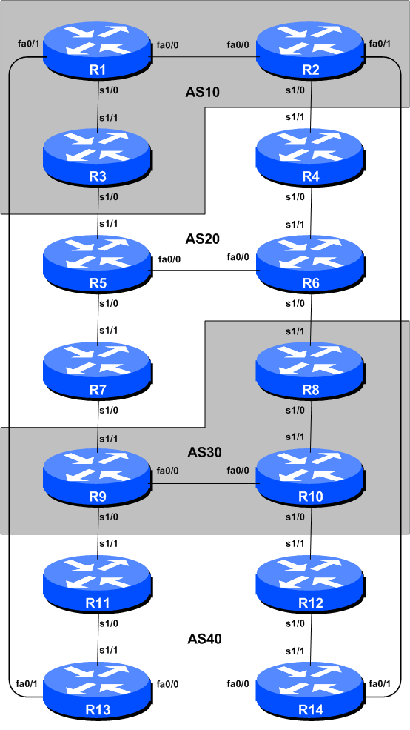
Figure 1 – BGP AS Numbers
Lab Notes

The purpose of this module is to introduce the student to external BGP (eBGP). This is the relationship between different autonomous systems in an “Internet”. The classroom is split into four distinct networks, and the teams belonging to each network work together as a typical ISP. Each AS has two links to its neighbouring ASes, and this feature will used throughout a significant portion of this workshop.

The connectivity shown in the diagrams represents links between AS’s. It is assumed that all the routers within an AS are physically connected to each other as per Figure 1.

Note: this IPv6 module is intended to be completed after the IPv4 version of this module.

Lab Exercises

- Connect routers as shown in Figure 1. All routers within an AS must be physically connected and reachable. The relationship between the ASes is as drawn in Figure 2 and gives a view which can be related to the “real world”.
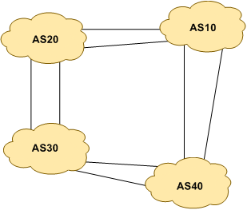
Figure 2 – AS relationship

- Remove any IPv6 addressing. Before we proceed to even think about configuring the routing protocols to match the above AS layout, we need to tidy up the addressing from previous modules. In this step we remove any remaining IPv6 addresses from all physical interfaces, and the loopback interface. This effectively takes the lab back to the configuration it had prior to step 10 in Module 1. Don’t forget to remove all the IPv6 addressing.

- IPv6 Addressing. As we did in step 5 of Module 1, we need to come up with a sensible and scalable addressing plan for each AS in this network. Each AS gets their own address block, again a /20 (typical minimum allocation for a starter ISP). This address block should be assigned to links and loopbacks on the routers making up each ASN. The allocations are as follows:

AS10 2001:db8::/32
AS20 2001:db9::/32
AS30 2001:dba::/32
AS40 2001:dbb::/32

Again we need to divide up each address block so that we have customer address space, network infrastructure address space, and some space for loopbacks. Figure 3 reminds how this could be done:
2001:db8::/32 network block

2001:db8:1::/48
2001:db8:ffff::/48
2001:db8::/64
2001:db8:0::/48

Customer Address Space
Loopbacks
Network Infrastructure

Figure 3 – Dividing allocated block of /20 into Customer, Infrastructure and Loopbacks

Please refer to the accompanying hand out for the address plan which should be used for this module onwards – it is entitled “Addressing Plan – Modules 6 to 9”. As with Module 1, configure the addresses on each interface which will be used for this module, and check basic IP connectivity with your immediately adjacent neighbours.

- Router Loopback Interface Addressing. As the minimum subnet size possible for IPv6 is a /64, we will assign the first /64 out of our /48 infrastructure block to be used for loopbacks even though each AS has either 3 or 4 routers in it. The loopback address assignments which will be used for this module are below:

Router1 2001:db8::1
Router2 2001:db8::2
Router3 2001:db8::3
Router4 2001:db9::1
Router5 2001:db9::2
Router6 2001:db9::3
Router7 2001:db9::4
Router8 2001:dba::1
Router9 2001:dba::2
Router10 2001:dba::3
Router11 2001:dbb::1
Router12 2001:dbb::2
Router13 2001:dbb::3
Router14 2001:dbb::4

- Configure IPv6 OSPF on the routers within each AS. In each AS configure IPv6 OSPF routing. This means setting up the OSPF process, marking internal interfaces as non-passive, and then configuring each internal interface and the loopback with the OSPF process. All the routers in an AS will be in the same OSPF area 0 and use the same OSPF process ID.

OSPF should be configured on internal interfaces only. You do not want to set up adjacencies with devices outside your AS. Make sure that there are no ipv6 ospf commands on external interfaces. A side effect of this is that external link addresses will not appear in the IGP (see the next section discussion iBGP deployment).

For example, Router 1, with two interfaces connecting to other routers in their AS, would have the following:

ipv6 router ospf 10
passive-interface default
no passive-interface fastethernet 0/0 ! adjacencies only on fa0/0...
no passive-interface serial 1/0 ! ...and ser1/0
log-adjacency-changes
!
interface fastethernet 0/0
ipv6 ospf 10 area 0
interface serial 1/0
ipv6 ospf 10 area 0
interface loopback0
ipv6 ospf 10 area 0
!

Notes:
- Passive-interface default makes sure that OSPF does not attempt to set up adjacencies on any interfaces apart from those specified by the no passive-interface commands.
- The number following “ipv6 router ospf” is a process ID and is used inside the router only (so it can be any number). But for this lab we recommend the OSPF process ID be the same as the AS number (which is the convention used by a number of ISPs).

- OSPF on Point-to-Point Ethernet Links. One feature mentioned in the OSPF for ISPs presentations was the option to modify OSPF’s behaviour on point-to-point broadcast media links, such as Ethernet, when there are only two devices on that media. If we declare such a situation to be point to point, then OSPF does not try and determine a designated or backup designated router; furthermore, there will be an improvement/simplification in SPF calculations and memory requirements on the router.

Those router teams which have OSPF configured over an Ethernet interface should now convert OSPF to point to point mode, for example:

interface fastethernet 0/0
ipv6 ospf network point-to-point

The result will be that the DR or BDR entry in the status column of “show ipv6 ospf neighbor” will disappear, to be replaced with a FULL. The link is now treated like a point-to-point serial connection.

- Ping Test. Check the IPv6 routes known via OSPF. Make sure you can see all the networks within your AS. Ping all loopback interfaces within your AS. Use the “show ipv6 ospf neighbor” and “show ipv6 route” commands. If you cannot see the other routers in your AS, you will not be able to bring up BGP in the next steps.

- Save the configuration. Don’t forget to save the configuration to NVRAM!

Checkpoint #1 : call the lab assistant to verify the connectivity.

- Intra Area Authentication. OSPF supports router authentication within areas. This is quite important inside ISP networks to prevent the introduction of improperly configured or unintended equipment.

Each team will turn on authentication for area 0 using the area N authentication command. An example configuration for Router6 might be:

ipv6 router ospf 20
area 0 authentication ipsec spi 256 md5 0123456789ABCDEF0123456789ABCDEF
!

Notice now that the OSPF adjacencies do not come up unless the neighbouring router has also entered the same configuration and key. Notice also how the OSPF adjacencies timed out after the configuration was entered – the adjacent router still had not set up OSPF neighbour authentication. Once they also have done this, the adjacency is re-established.

Also, if we want to configure neighbour authentication per area but disable it on a per link basis, we need to use the authentication null option. The following example shows how to disable neighbour authentication on one specific interface, hssi 5/0.

interface hssi 5/0
ipv6 ospf authentication null
ipv6 ospf 1 area 10

Note: Wherever an OSPF session is configured from now on in the workshop, all Router Teams MUST use passwords on these OSPF sessions.

Checkpoint #2 : call the lab assistant to verify the connectivity.

- Configure iBGP peering between routers within an AS. Use the loopback address for the iBGP peerings. Also, configure the network command to add the address block assigned to each Router Team for advertisement in BGP.

router bgp 10

no bgp default ipv4-unicast

bgp log-neighbor-changes

address-family ipv6
no synchronization
network 2001:db8::/32
neighbor 2001:db8::2 remote-as 10
neighbor 2001:db8::2 update-source loopback 0
neighbor 2001:db8::2 next-hop-self
neighbor 2001:db8::2 description iBGP Link to R2
neighbor 2001:db8::3 remote-as 10
neighbor 2001:db8::3 update-source loopback 0
neighbor 2001:db8::3 next-hop-self
neighbor 2001:db8::3 description iBGP Link to R3
!
ipv6 route 2001:db8::/32 Null0

- Next-hop-self configuration. The previous step introduced the next-hop-self configuration command. Referring to the BGP presentation, the next-hop-self configuration makes the iBGP speaking router use the iBGP source address (in this case the loopback) rather than the external next-hop address (as per the BGP specification). This is industry best practice and means that ISPs do not need to carry external next-hops in their IGP.

- Test internal BGP connectivity. Use the BGP Show commands to ensure you are receiving everyone's routes from within your AS.

- Configure passwords on the iBGP sessions. Passwords should now be configured on the iBGP sessions. Review the presentation why this is necessary. Agree amongst all your team members in your AS what the password should be on the iBGP session, and then apply it to all the iBGP peerings on your router. For example, on Router2’s peering with Router3, with “cisco” used as the password:

router bgp 10

address-family ipv6

neighbor 2001:db8::3 password cisco

IOS currently resets the iBGP session between you and your neighbouring router whenever an MD5 password is added. So when passwords are added to BGP sessions on live operational networks, this work should be done during a maintenance period when customers know to expect disruptions to service. In the workshop lab, it doesn’t matter so much. (Future IOS releases will avoid having this rather serious service disruption.)

Watch the router logs – with the BGP session neighbour changes being logged, any mismatch in the password should be easy to spot.

Checkpoint #3: Call the lab assistant and demonstrate the password as set on the iBGP session. Once confirmed by the lab assistant, move on to the next steps.

- Configure eBGP peering. Use Figure 1 to determine the links between the AS’s. Addressing for eBGP links between 2 AS’s will use the point-to-point interface addresses, NOT the loopback addresses (review the BGP presentation if you don’t understand why). So, for Router1’s peering with Router13, the configuration might look like:

router bgp 10

address-family ipv6
neighbor 2001:db8:0:4::1 remote-as 40
neighbor 2001:db8:0:4::1 description eBGP to Router13

Use the BGP Show commands to ensure you are sending and receiving the BGP advertisements from your eBGP neighbours.

Q. Why can’t the loopback interfaces be used for the eBGP peerings?

A. The IP address of a router’s loopback interface is not known to external BGP peers, so the external peers will have no way of knowing how to contact each other to establish the peering.

Q. Which BGP show command allows you to see the state of the BGP connection to your peer?

A. Try show bgp ipv6 unicast neighbor x.x.x.x – this will give detailed information about the state of the peer. There are subcommands of this one, giving more information about the peering.

Q. Which BGP Show command will allow you to see exactly which networks you are advertising and receiving from your eBGP peers?

A. Try show bgp ipv6 unicast neighbor x.x.x.x route – this will show which routes you are receiving from your peer. Likewise, replacing route with advertised-routes will list the networks which are being announced to your peer. (Note that in general ISP operational practice, there are caveats here – if you apply route-maps and some BGP policies, these will not be processed by the advertised-routes command. Use the advertised-routes subcommand with due caution.)

- Configure passwords on the eBGP session. Passwords should now be configured on the eBGP sessions between your and your neighbouring ASes. Agree between you and your neighbouring AS what the password should be on the eBGP session, and then apply it to the eBGP peering. For example, on Router2’s peering with Router4, with “cisco” used as the password:

router bgp 10

address-family ipv6

neighbor 2001:db8:0:3::1 password cisco

As previously for the iBGP session, watch the logs for password mismatches, or missing passwords. As with the iBGP sessions previously, you will find that the router will reset the eBGP session as soon as the password is applied.

Note: Wherever a BGP (either iBGP or eBGP) session is configured from now on in the workshop, all Router Teams MUST use passwords on these BGP sessions.

Checkpoint #4: Call the lab assistant and demonstrate the password as set on the eBGP session. Once confirmed by the lab assistant, move on to the next steps.

- Adding a “customer” route into BGP. As we did in Module 1, we are now going to add a “customer” route into BGP on each router. We don’t have any “customers” as such connected to our routers in the lab, so we are going to simulate the connectivity by simply using a Null0 interface. The “customer” address space that each router team will introduce into the iBGP is listed below – again we will each use a /48, for simplicity’s sake.

R1 2001:db8:1::/48
R2 2001:db8:2::/48
R3 2001:db8:3::/48
R4 2001:db9:1::/48
R5 2001:db9:2::/48
R6 2001:db9:3::/48
R7 2001:db9:4::/48
R8 2001:dba:1::/48
R9 2001:dba:2::/48
R10 2001:dba:3::/48
R11 2001:dbb:1::/48
R12 2001:dbb:2::/48
R13 2001:dbb:3::/48
R14 2001:dbb:4::/48

Each team should now set up a static route pointing to the NULL0 interface for the /48 that they are to originate. Once the static is set up, the team should then add an entry into the BGP table. Here is an example for Router8:

ipv6 route 2001:dba:1::/48 Null0

!

router bgp 30

address-family ipv6

network 2001:dba:1::/48

!

- Check the BGP table. Are there routes seen via show bgp ipv6? If not, why not? Once every team in the class has done their configuration, each team should see the aggregate from each AS as well as the fourteen /48s introduced in the previous step. If this is not happening, work with your neighbours to fix the problem.

Checkpoint #5: Call the lab assistant to verify the connectivity. Use commands such as “show ipv6 route sum”, “show bgp ipv6 unicast sum”, “show bgp ipv6 unicast”, “show ipv6 route”, and “show bgp ipv6 unicast neigh x.x.x.x route | advertise”. There should be 4 aggregate prefixes (one for each ISP) and the 14 customer /48’s in the BGP table.

- The Importance of Aggregation. Each AS was allocated a /32 address block. It is expected by all Internet operators that any address space an ISP is using is aggregated as much as possible before it is announced to the rest of the Internet. Subdividing the address space inside an AS is perfectly acceptable and obviously very common (as we have done here) – but most operators consider leaking this subdivided address space out to the Internet at large antisocial and unfriendly.

Q. How do you automatically aggregate via BGP smaller address blocks from within your network to a larger address block outside your network? Hint: Review the BGP documentation.

A. The “aggregate-address” command is quite often used to achieve this.

We are not doing any filtering or limitation of the announcements of the “customer” address blocks we have introduced into each ASN. This will be one of the goals of the next modules in the workshop.

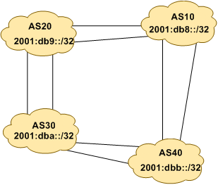
Figure 4 – Aggregates for each ASN

Review Questions

- How many origin types exist in BGP?

- List the origin types. Hint: Review the BGP presentations.

- How are they used?

- Why are passwords necessary on both iBGP and eBGP sessions? What do they protect against?

- Why is aggregation important for the Internet?

